

**Enjoy your time in our hotel!**

**Team members:**   
  
Kim Aleksandra U1810002

Suleymanova Firuza U1810029

Abdullaev Oybek U1810268

Abdukadirov Jakhangir U1810040

Mirzakhalilova Madina U1810113

**GitHub Repo:** <https://github.com/iuthub/ip-group-project-day-spisat-1/>

**Web Site:** <http://thechemodanhotel.herokuapp.com/>

**Credentials:**

Customer: [vasya@go.com](mailto:vasya@go.com) | vasya123

Admin: [admin@go.com](mailto:admin@go.com) | admin

[The online version of this report](https://docs.google.com/document/d/15X04nw9tx-wPXeBsfx1zaQtx4Ewb-xCg/edit#)

## Business activity

“The Chemodan” Hotel is one of the best places where you can take a rest after your flight or meeting. Access to the high-speed Internet will give you the ability to stay in touch with your family, friends, and colleagues. Delicious dishes in our restaurant and an outdoor pool will not leave you indifferent, while various entertainment clubs will help you to have fun. For those who come with families, our hotel has special family rooms and playground for little ones.

## Walkthrough

### Landing page

Advertises our hotel, gives brief information about us and contains all main divisions that provide the most convenient interaction between client and website. Here a user can select desired “check-in” and “check-out” dates (by default the date is set to one and two weeks later from today, respectively). This is to make it easier for customers to navigate with numbers.

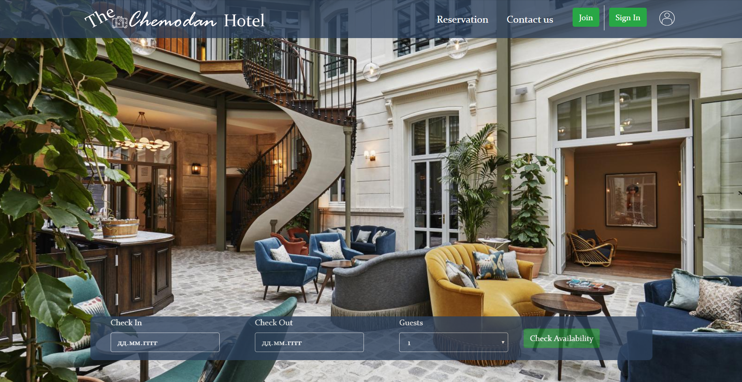  
  
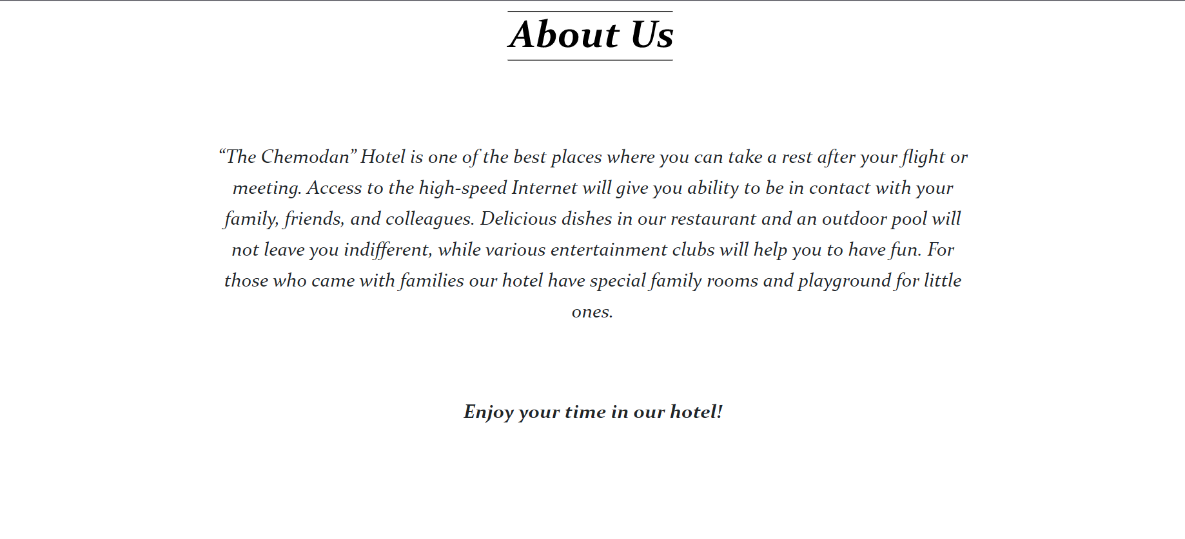 

### Rooms

In order to see all available rooms customer clicks to button “check availability”. Here we have all types of available rooms with its prices that our hotel provides in the mentioned period of time. The rooms that already have been reserved before will not be available and demonstrated.

*Technical information:* For finding free date slots for rooms used the following [SQL solution](https://stackoverflow.com/questions/52740231/sql-find-free-slots-for-booking-system) which we translated into Laravel’s database query.

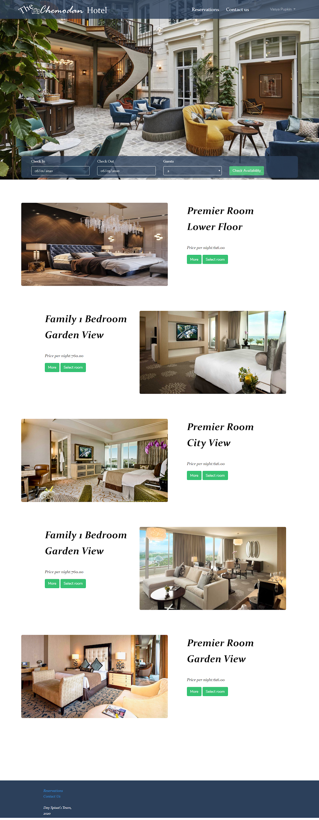

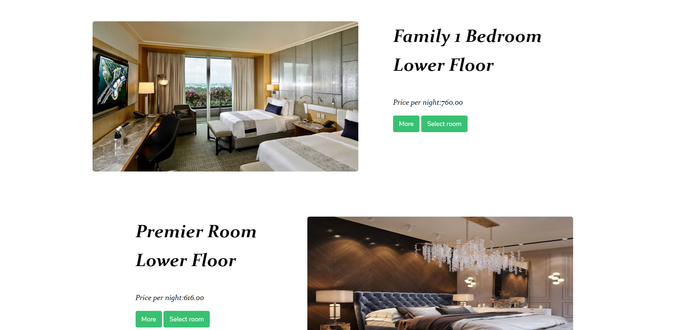

**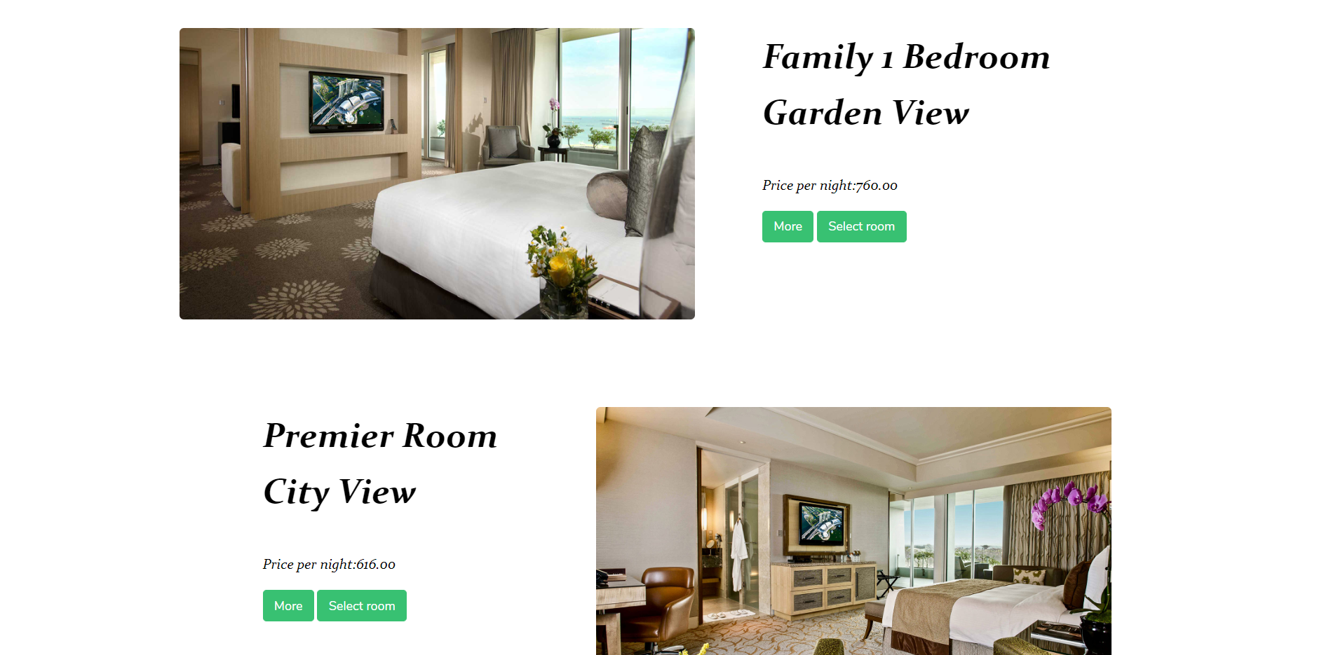  
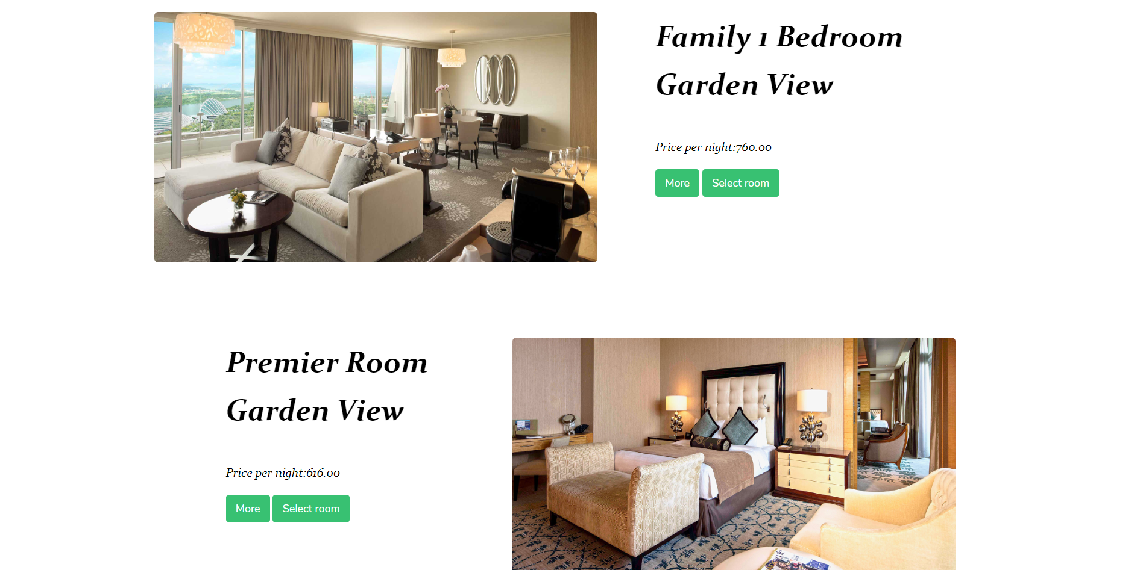**

### Room details

To get more detailed information about any available room customer can click to the button “more”, where he or she can find all necessary information about the room and its furnishings. We have tried to make it as easy as possible to get acquainted with it.

*Technical information:* Used standard [Bootstrap modal](https://getbootstrap.com/docs/4.0/components/modal/)

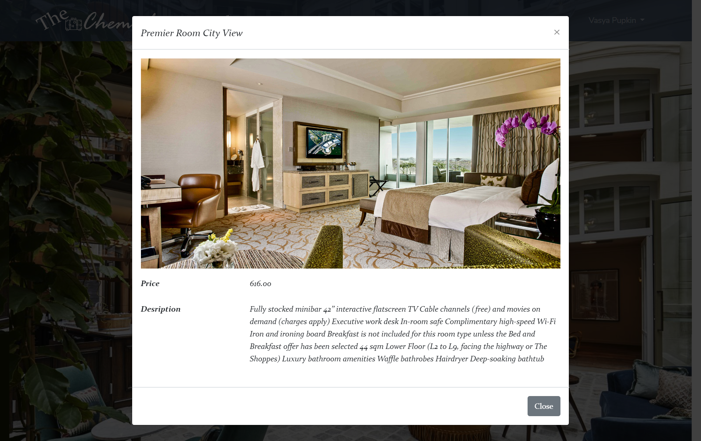

### Reservation

After selecting the room, the customer needs to provide all necessary information and fill the lines provided below. After making a reservation customer may check the status of his booking in the section “Reservations”. Also here can be found information about all reservations that the client has already made.

*Technical information:* Here we implemented validation both on client and server sides. If the form input is valid then the browser sends a POST request using AJAX to the server to add the reservation details to the database.

Validation criteria:

|  |  |
| --- | --- |
| First Name, Last Name | Required |
| Card Number | Required, exactly 16 digits |
| Cvc | Required, exactly 3 digits |
| Street, City, Country | Required |
| Phone number | Required, matches format +998-99-1234567 |
| Postal code | Required, exactly 7 digits |
| City name | Required, words only |
| Passport number | Required, matches format AA1234567 |

*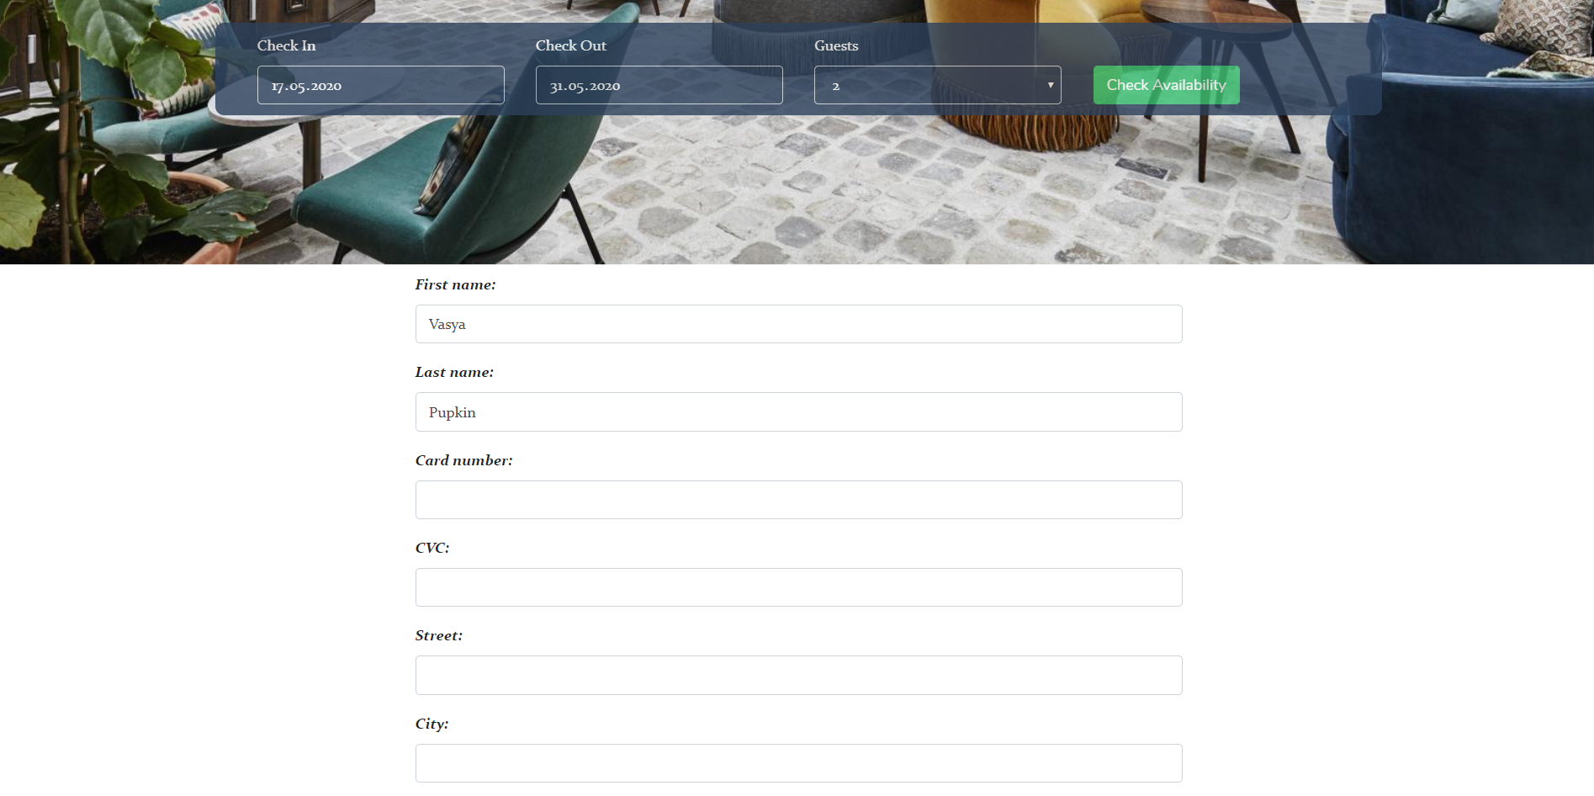  
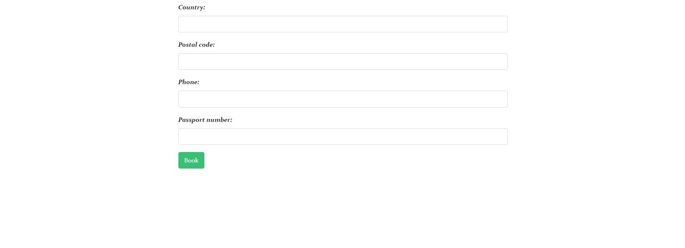  
  
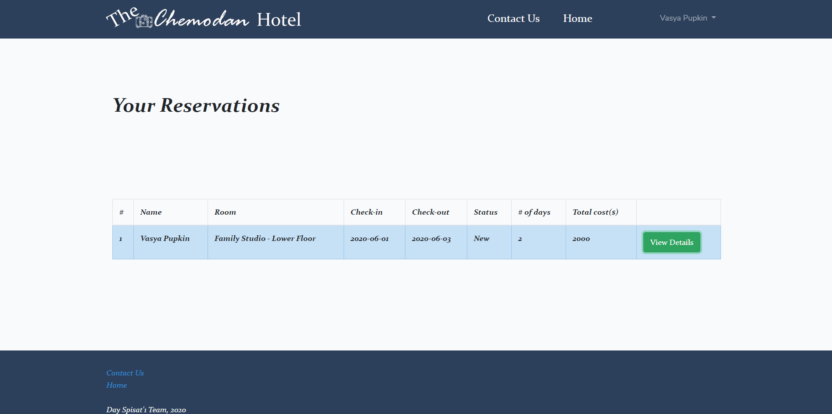*

### “Sign Up” and “Sign In”

Authorization is made to restrict access to certain parts of the portal. For example, unauthorized users cannot book rooms. If admin logs in, he is redirected to an admin panel page.

*Technical information:* Used a standard Laravel’s authorization engine but with custom validation on server side:

|  |  |
| --- | --- |
| First Name, Last Name | Required |
| Card Number | Required, exactly 16 digits |
| Date of birth | Required, date format |
| Username | Required, contains at least 5 alphanumeric characters, unique |
| Password | Required, contains at least 5 alphanumeric characters, unique |
| Email | Required, standard email format |

*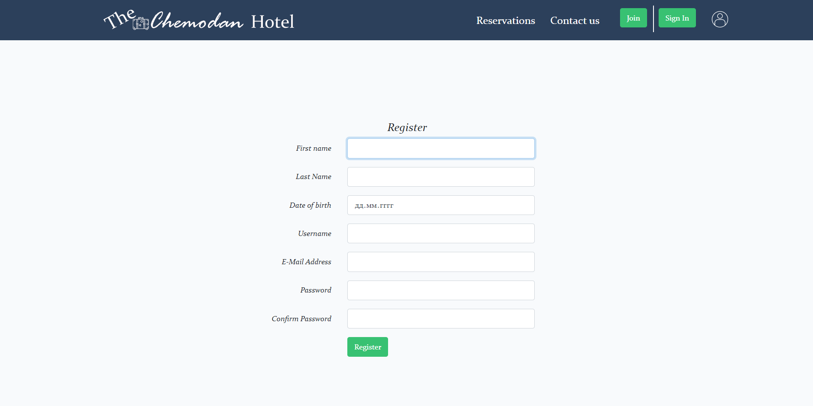  
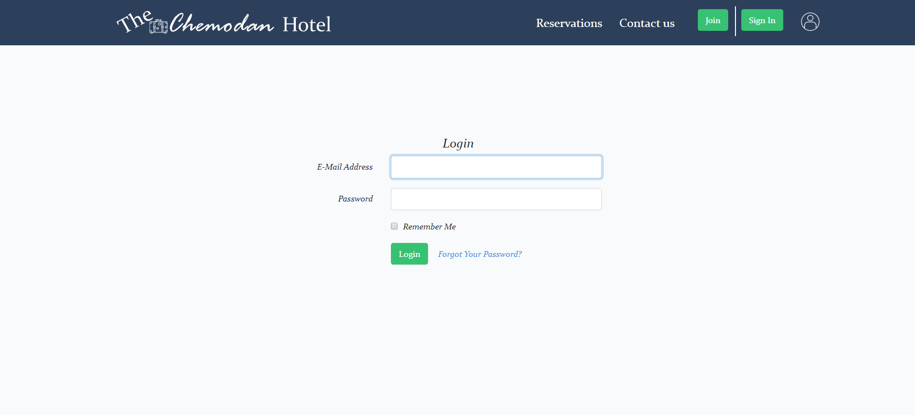*

### Contact us

If a customer has any questions or suggestions, he can contact us by sending a message in the form provided below.

*Technical information:* This form send an email to the address [thechemodanhotel@gmail.com](mailto:thechemodanhotel@gmail.com). As a guide, we used this [tutorial](https://youtu.be/rn0BHdqrock). It also has a server-side validation:

|  |  |
| --- | --- |
| Name | Required, min 5 letters |
| Email | Required, standard email format |
| Message | Required, min 5 characters |

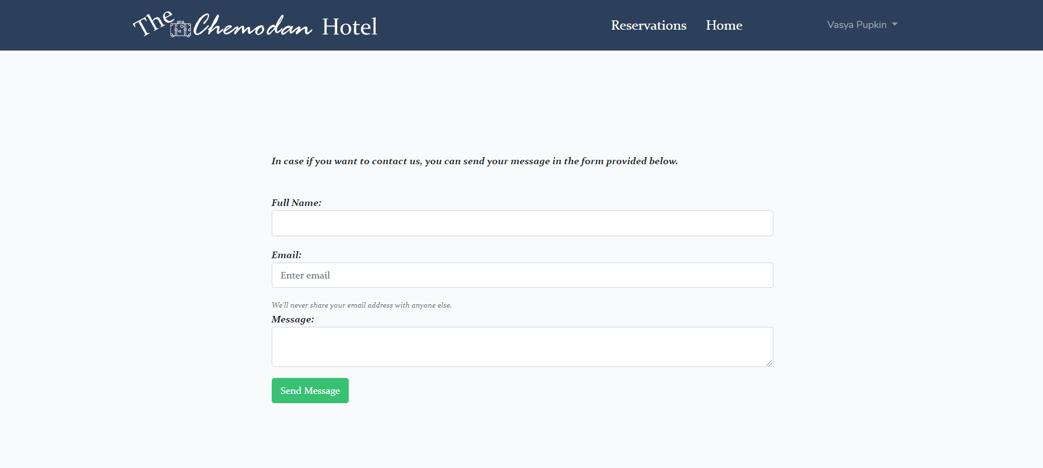

### Admin panel - Reservations

From the admin side, it can be observed all reservations that customers have done. The administrator sees all necessary information and changes the status for each booking (cancel or confirm). After that, the customer will receive email notification of status update and may check his booking in his reservations

*Technical information:* The status updates here asynchronously so that the page did not update for each update. For better user experience rows with reservations are highlighted with corresponding colours (New - Blue, Confirmed - Green, Cancelled - Grey)

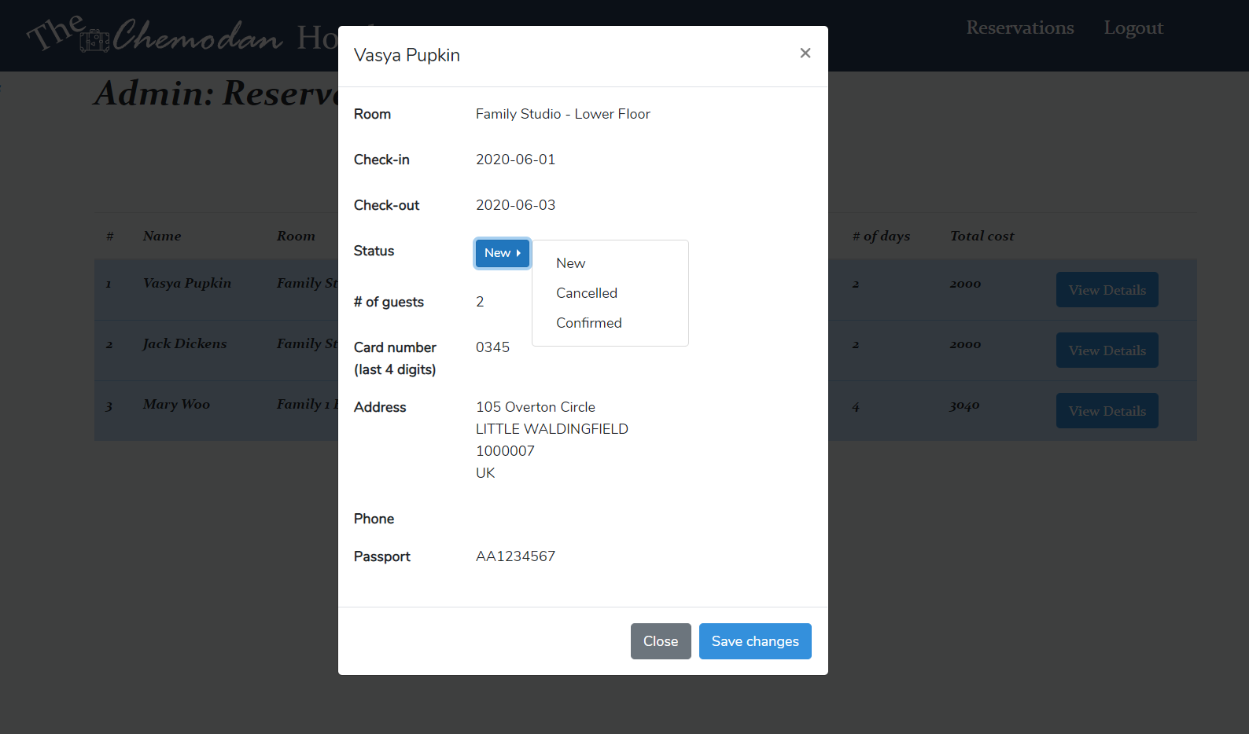

### Admin panel - Rooms

In the “Admin rooms” we have all the available rooms in our hotel and we can easily make some changes in information(edit) or delete the room from the list. Also, we have an “Add room” where we can add the new room with all the necessary information.

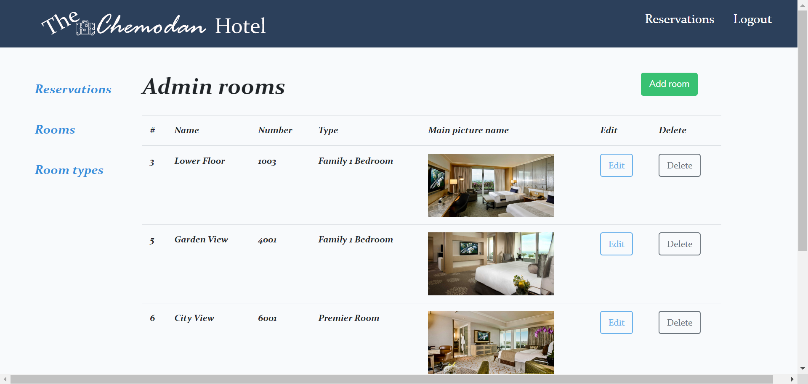  
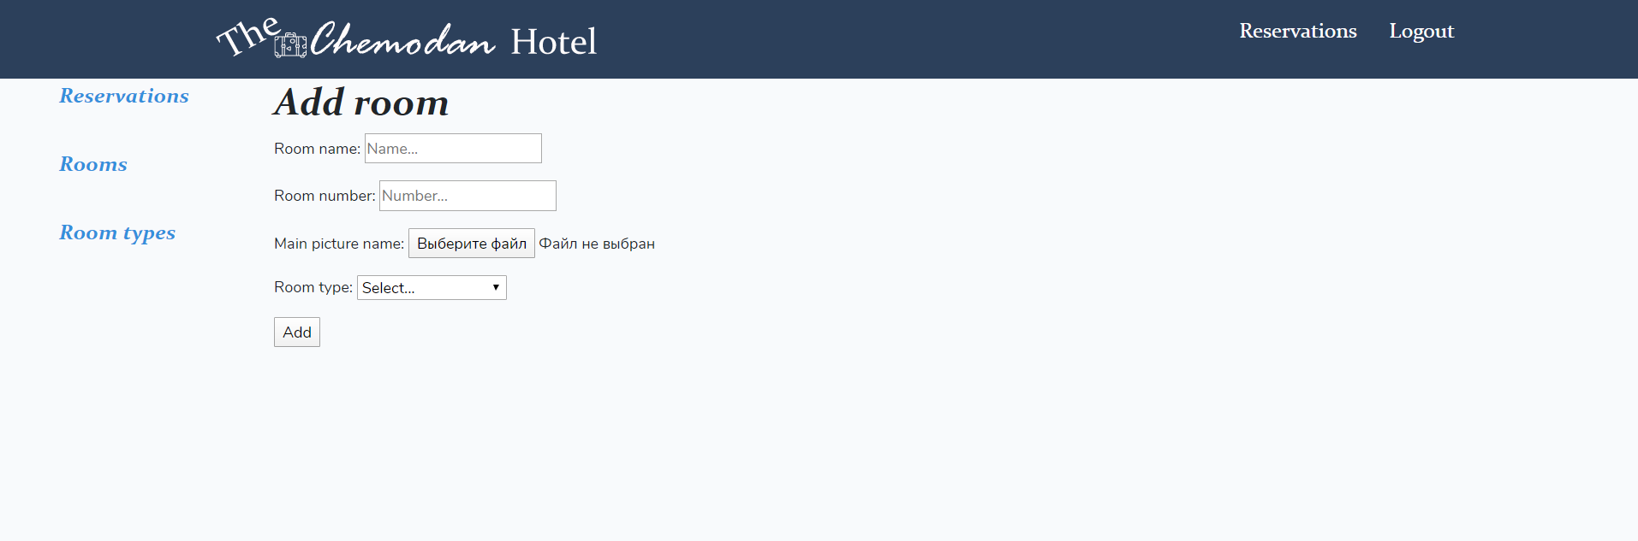

### Admin panel - Room types

In the “Admin room types”, we can make some editions in the descriptions of the types of rooms or we may add or delete them.

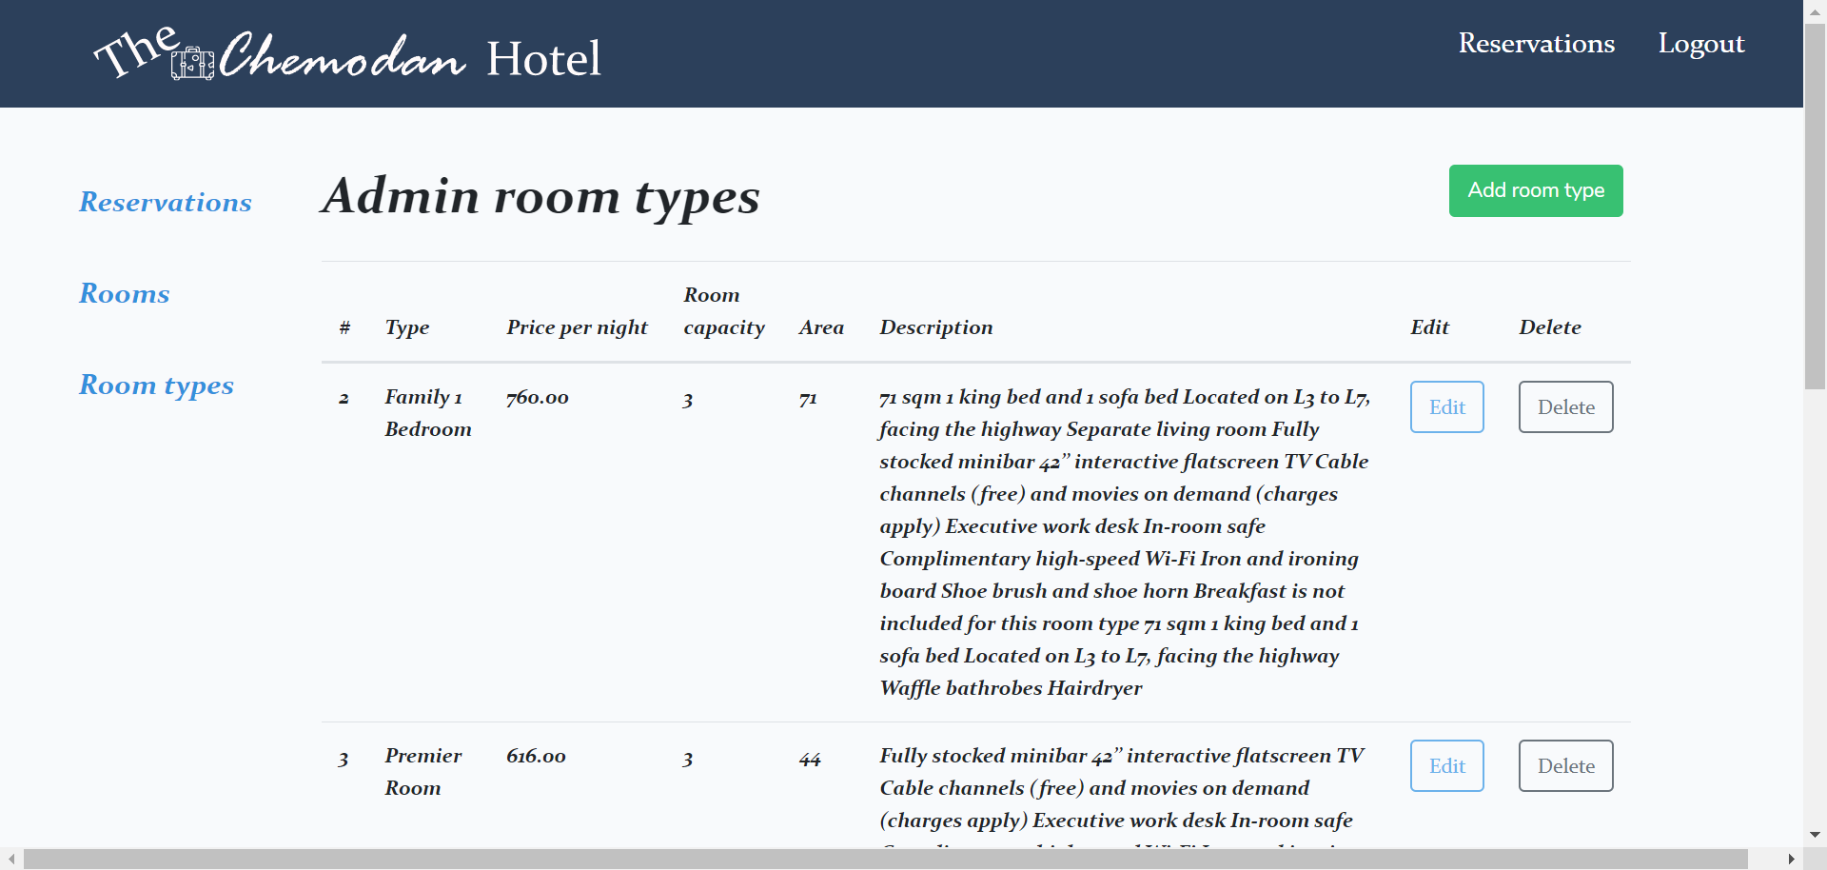

## 

## Development processes

### Database structure

Relationships:

users hasMany reservations

reservations *hasOne* payment_details

rooms hasMany reservations

room_types *hasMany* rooms

### Main site user flow diagram

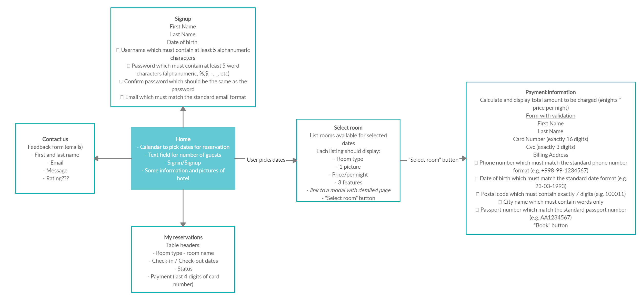

**Admin panel user flow diagram**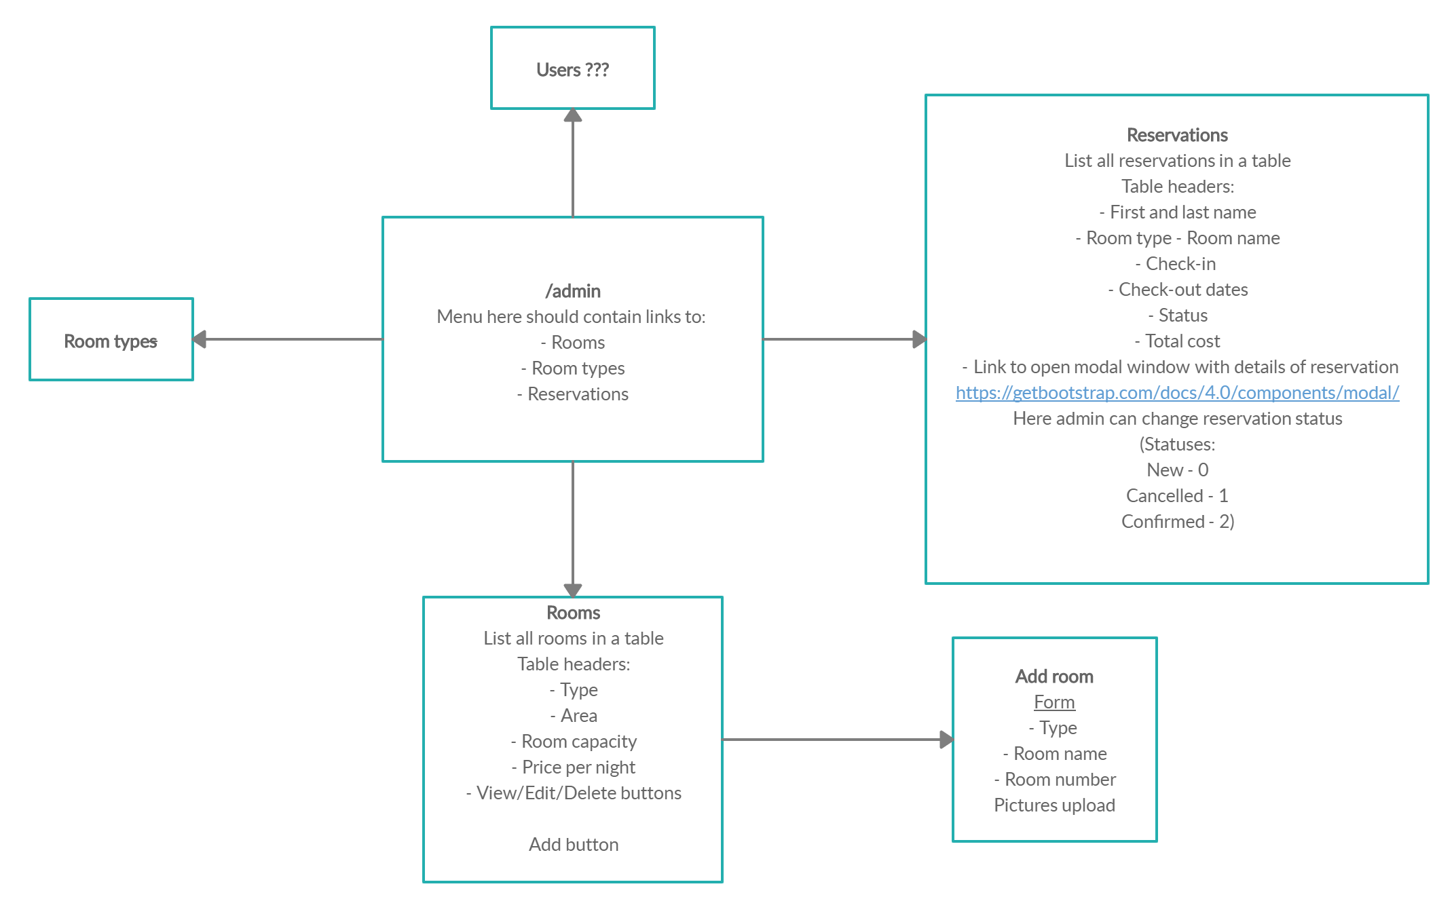

### Contribution

1. Abdullaev Oybek (U1810268) - HTML pages, views, routes, rooms (admin, user), payment details

2. Kim Alexandra (U1810002) - Auth, DB migrations, validation, admin reservations, rooms filtration, hosting deployment and report

3. Suleymanova Feruza (U1810029) - design, HTML & CSS and Laravel templating

4. Abdukadirov Jakhangir (U1810040 - models, validation, HTML & CSS and report

5. Mirzakhalilova Madina (U1810113) - design and HTML & CSS

**First meeting:**   
 1. Abdullaev Oybek (U1810268) - HTML pages, basic views, routes  
 2. Kim Alexandra (U1810002) – DB migrations   
 3. Suleymanova Feruza (U1810029) - design and front-end  
 4. Abdukadirov Jakhangir (U1810040 – models   
 5. Mirzakhalilova Madina (U1810113) - design and front-end  
  
**Second meeting:**  
 1. Abdullaev Oybek (U1810268) – select rooms, contact us (Emails)  
 2. Kim Alexandra (U1810002) – rooms, payment information, seeders   
 3. Suleymanova Feruza (U1810029) - design and front-end  
 4. Abdukadirov Jakhangir (U1810040 – models, contact us validation  
 5. Mirzakhalilova Madina (U1810113) - design and front-end

**Third meeting:**

1. Abdullaev Oybek (U1810268) – admin rooms and room types - CRUD  
 2. Kim Alexandra (U1810002) – validation (auth, payment details)   
 3. Suleymanova Feruza (U1810029) - design and front-end (design admin)  
 4. Abdukadirov Jakhangir (U1810040 – report, user reservations  
 5. Mirzakhalilova Madina (U1810113) - design and front-end (design user)